Task 1:
First : input Sum1 and Sum2
Second : add Sum1 + Sum2 into = Total Sum
Third : Output Total Sum

Task 2:
Start
Declarations
num number1
num number2
num sum
output "Enter number 1"
Input number 1
output "Enter number 2"
Input number 2
sum = number1 + number2
output "Sum is: ", sum
Stop

Task 3:
Actual Output : Enter Number 1,
Enter Number 2,
Sum is 50.

Task 4 :
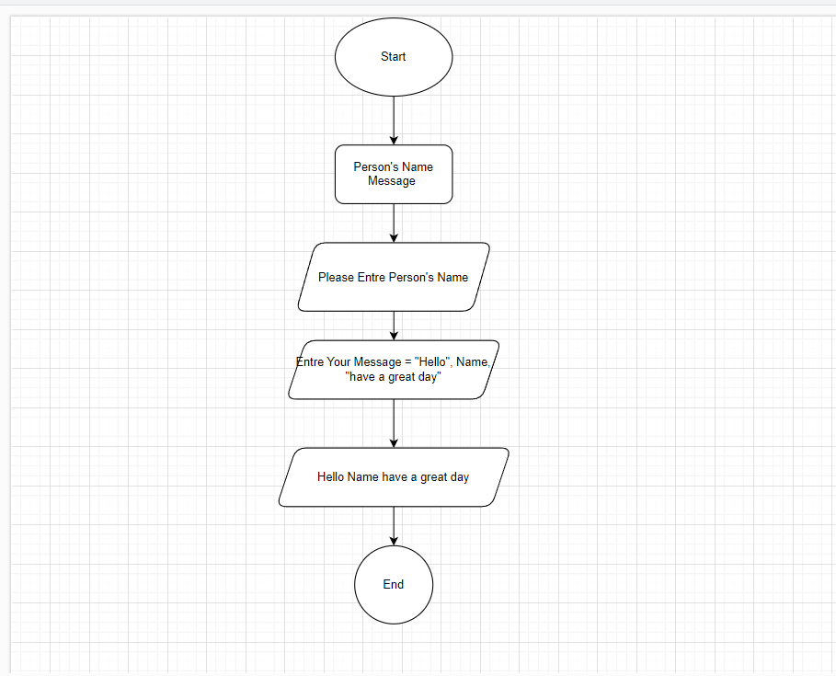

Task 5:
